**Curriculum vitae** 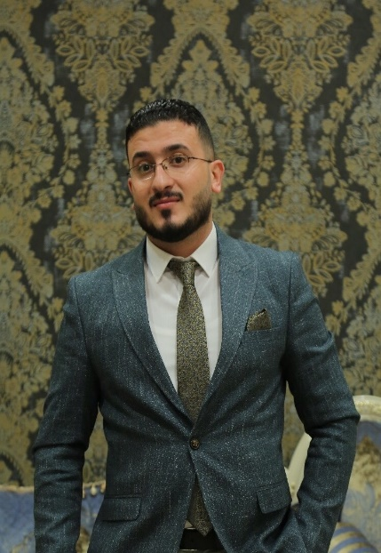

**Saif Abdul Khaliq Hussein**

**Gender:** male

**Date of Birth:** 24.04.1989

**Marital status:** Married

**Nationality:** Iraqi

**Aaddress:** Baghdad-Alatefea

**Email: Saifabd89@gmail.com**

**MOB: +964 7703208429**

**Objective:**

I am looking forward to become a member in a leading companies and business, where my skills will be enhanced and developed, I'm ready to work in any field in anywhere to prove myself and I'll continue learning and practicing in fields which I'll work in to deliver better results.

**EDUCATION:**

* I have Bachelor in Chemistry from the University of Al Mustansiriya – Collage

Of-Sciences – in 2010 – 2011

**Work Experience:**

**Al Rasoom al Alamiya for furniture**

**Head of after sales Oct-2018 – till now**

* Manage all department units (installation, transportation, workshop and call center unit).
* Preparing an integrated team to achieve the company's objectives.
* Develop new customers and be responsible for customer due diligence.
* Build and maintain the customer relationships.
* Investigation, tracking and analysis of customer needs, provide customer service in a timely and effective manner.
* Find appropriate solutions to all complaints that increase customer satisfaction.
* Proposing new ideas to reduce financial costs on the company.
* Motivate employees to achieve company targets by complete all orders for customer.
* Analyzing all inquiries, complaints, surveys of customers so that can build strong relationship with our customers.
* Monitor and evaluate staff performance to improve their skills ... The end result is getting customer satisfaction.
* prepare reports to the high management.

**Group BCI Samsung**

**Sales operator & demand planning Dec-2017 till act-2018**

**Job Duties and Responsibilities:**

* Prepares the stock distribution for the supervisors upon the Sales Representative's order on a daily basis.
* Prepares stock distribution of the Key Account Executives of both top 50 and wholesalers.
* Prepares the stock distribution for sub warehouses upon the Showrooms Supervisors request.
* Organizes the top 50 and wholesalers’ orders.
* Monitors the account receivable for customers and reports any occurring problem in checks or credit to the Sales Manager on a daily basis.
* Follows up on and coordinates with the top 50 and wholesalers Key Accounts monthly target and incentives papers.
* Helps in any open market campaigns.
* Prepares the delivery requests and provides it to the Distributions and Warehousing Supervisor to arrange delivery of the top clients, wholesaler customers and the company sub warehouses with mentioning any special instructions upon priorities.
* Issue any circulars related to the Sales Department.
* Daily sales report / channel / region /flag ship models**.**

**Group BCI Samsung Feb 2017 till Dec-2017**

**Customer service Team leader**

* Monitoring the team members' Quality (Customer service & technician team).
* Training and preparing new staff for their positions.
* Reporting to the high management.
* Propose appropriate business development solutions.
* Contact with dealers to suggest new offers and make dealings with them.
* Contact with customers to know the satisfied or unsatisfied and find suitable. solutions.
* Make daily stock taken for maintenance devices.
* Follow up payment for maintenance devices and deposit the cash to finance.
* To Make weekly and monthly KPI for teem.

**Itisaluna CDMA Telecommunication Co**

**Customer care Team leader Mar 2013-2017**

* Follow up Baghdad and Governorates brunch
* Visit Baghdad & governorates on monthly basis to follow up all details and make monthly stock taken for sales and monthly devices & scratch card
* Monitoring the team members' Quality (call center, support team)
* Handling the customer’ complaints by analysing them by checking them (using all the databases and other tools available).
* Follow up all customers complaints & make sure that all problems has been solved properly.
* Training and preparing new staff for their positions.
* Analysing customers complained that created by CCR and filter it.
* Reporting to the high management
* Follow up team performance

|  |  |
| --- | --- |
| **Itisaluna CDMA Telecommunication Co** |  |
| **Customer care representative Jun 2012-2013** | |

* Answer customer calls in a timely and professional manner
* Assist customers with billing inquiries
* Manage customer’s request to move, add, change or disconnect Services
* Making my reports and send it to my supervisor.
* Checking with the customers by calling them in-order to make sure that the complaint has been solved.

**Computer Skills**:

Experience in (Word &Excel &Power point &internet browsing) and high professional to communicate with other Good experience in manage team members.

**Training:**

* Training in Communication Skills in Itisaluna CDMA telecommunication Co
* Training in TABS system
* Training in OCS system
* Training Mena track system
* Training in managements skills
* Training in customer service & the body language with the customers.

**Spoken Languages**:

* Arabic (Native Language) Advanced: Speaking, Reading, & Writing English: Good level